Wellbore Diagram API Well No: 05-087-07205-00-
Owner: RITCHIE EXPLORATION, INC. Well Name: MERINO STATE #3
County: MORGAN Field: MESSEX Pool:
Coordinates: X 1320 FEL ;Y 330 FSL Sec: 36 Twp: 6N Rng: 55W
Note:Changes to the drawing do not effect the database

PRIOR PA

Bore Diameters (in)

Cement Top: 0' mthd:U
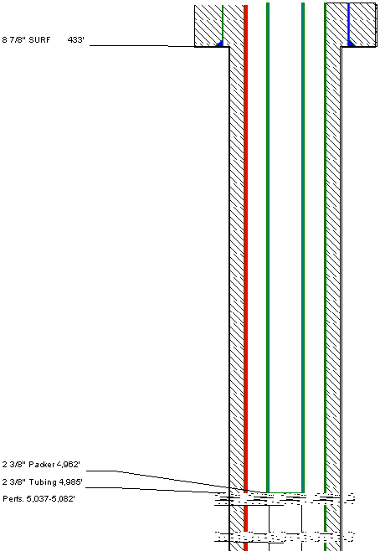 Cement Top:0’ mthd:U

8 5/8” Surf 129’

Probable Casing Leak @ 1025’

CMT Top @ 4548’ _____________

Perts. 5,447-5,458'
Total Vertical Depth 5, 734' =========
5 1/2" 1ST 5,733'
Pkr with on/off tool – no tubing @ 5005’

J- Sand Perfs. 5,083’-5,086’ _______
PBTD @ 5109’
4 ½” 1ST 5,148’

Total Vertical Depth 5,150’

