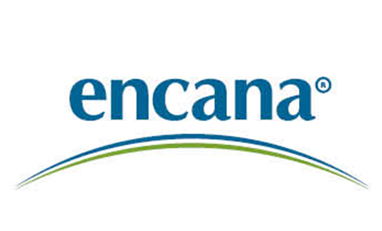

Scheidt State 3-16

Surface Casing Annular Fill

November 21, 2013

Engineer: Scott Reed

Workover Coordinator: Butch Till

Production Group Lead: Andrew Berhost

DJ Team Lead: Eric Root

Attachments:

Attachment 1 – Wellbore Diagram

Safety
Safety meetings are to be held with all service company personnel prior to each job. Wellsite supervisor must notify contractors as to known hazards of which the contractors may be unaware. Well site supervisor must ensure that all workers are aware of their responsibilities and duties under the EH&S guidelines. All safety meetings will be recorded on the Encana daily completion reports in Wellview.

Regulations
All verbal notifications and approval from government regulatory agencies will be recorded on the Encana daily report. The name of the individual contacted and the subject matter of approval or notification will be recorded.

Reason for Work
Offset to APC Underhill Pad

Objective:

Pull tubing, Un-land 4.5” casing and RIH with 1-1/4” String. Cement from 900’ to Surface casing. Run CBL.

Procedure:

- Hold a pre-job safety meeting. Discuss all aspects of the procedure with any involved personnel. Identify and address any safety concerns before the job begins.

- MIRU pulling unit. Kill well with produced water.

- ND wellhead, NU BOP.

- POOH with tubing. Replace joints as needed.

- RU E-line.

- RIH and set CIBP @ 8050’.

- Unland 4-1/2” production casing.

- RIH down 4-1/2” by 8-5/8” annulus with 1-1/4” tubing to 900’.

- Establish circulation and pump 140 sxs of class G neat cement, taking returns up annulus to surface.

- POOH and lay down 1-1/4” tubing.

- Reland 4-1/2” casing

- Run CBL and log from 1500 to surface’

- RD E-line.

- ND BOP, NU wellhead.

- RDMO Workover rig.
Attachment #1 – Wellbore Diagram 

