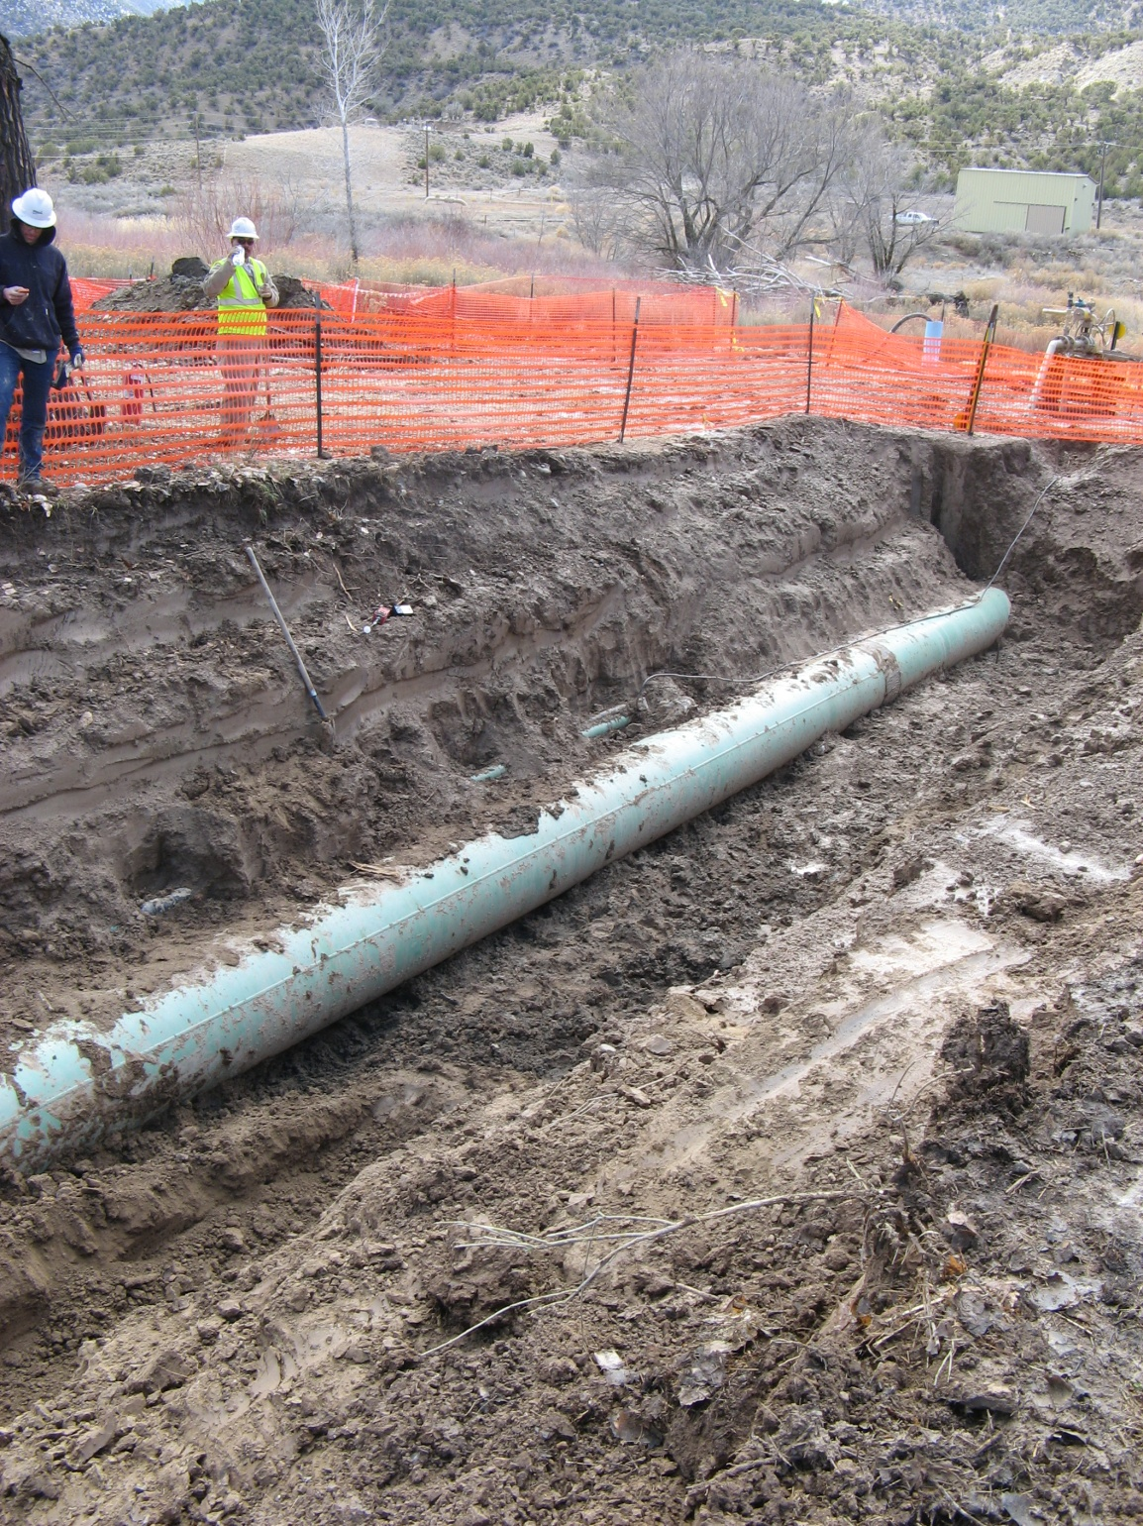
File Name: 084.jpg
Parachute Valley Gathering System Release, Project #2120
Date: 03-21-2013
Photographer: Karen Spray
Facing: southwest
Description: Excavation of gathering line. Aboveground valve set on right. Parachute Creek beyond that.
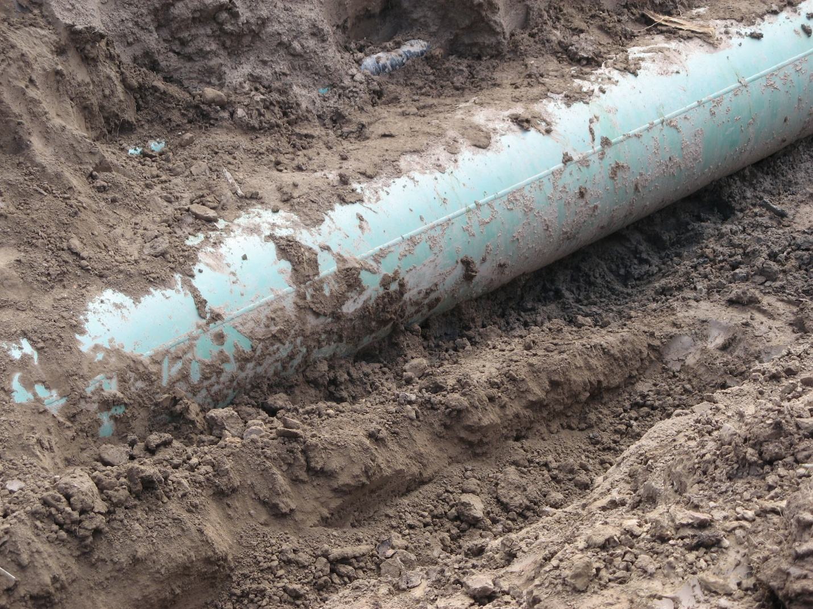
File Name: 085.jpg

Parachute Valley Gathering System Release, Project #2120
Date: 03-21-2013
Photographer: Karen Spray
Facing: southwest
Description: Close up of excavation of gathering line. NGL line (black) visible above gathering line.

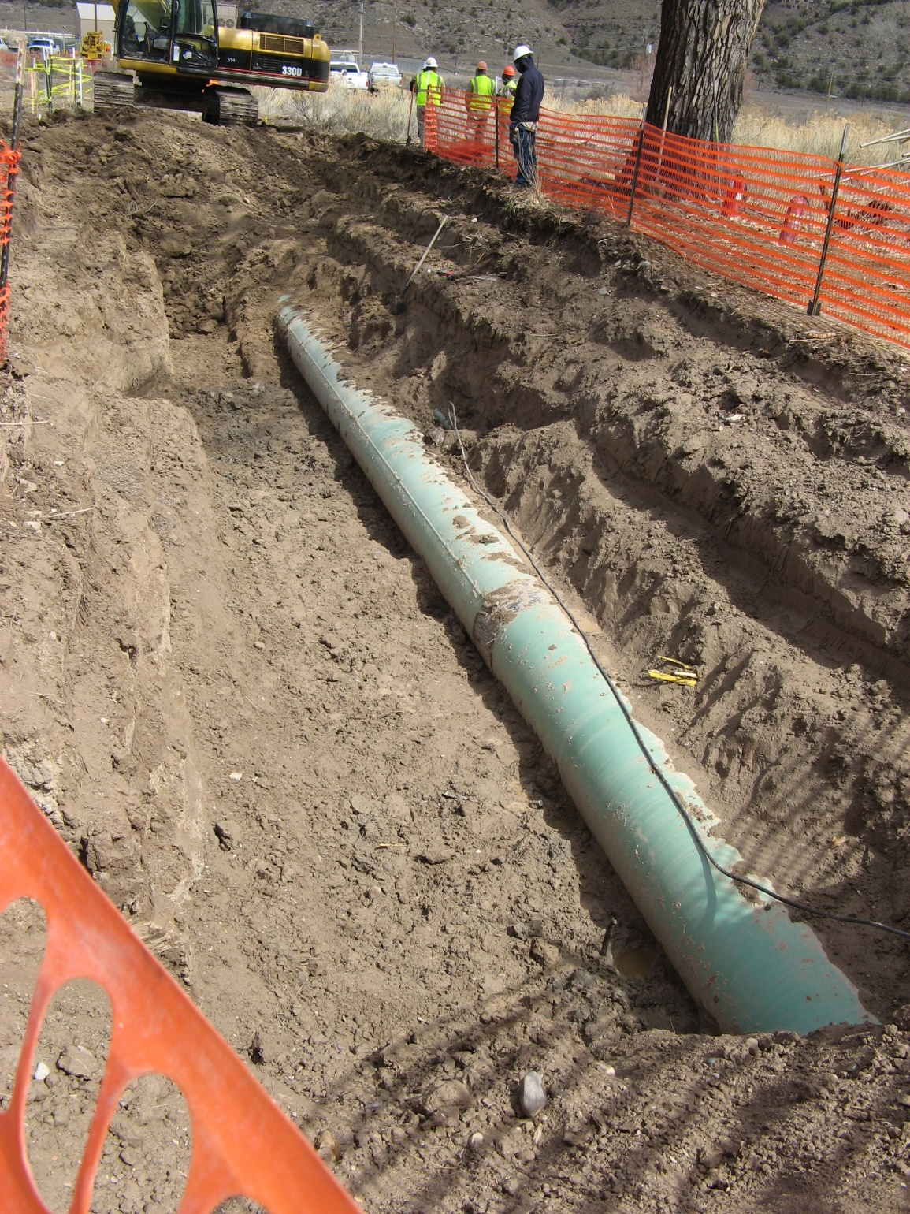
File Name: 086.jpg

Parachute Valley Gathering System Release, Project #2120
Date: 03-21-2013
Photographer: Karen Spray
Facing: southeast
Description: Excavation of gathering line. Looking towards active excavation.

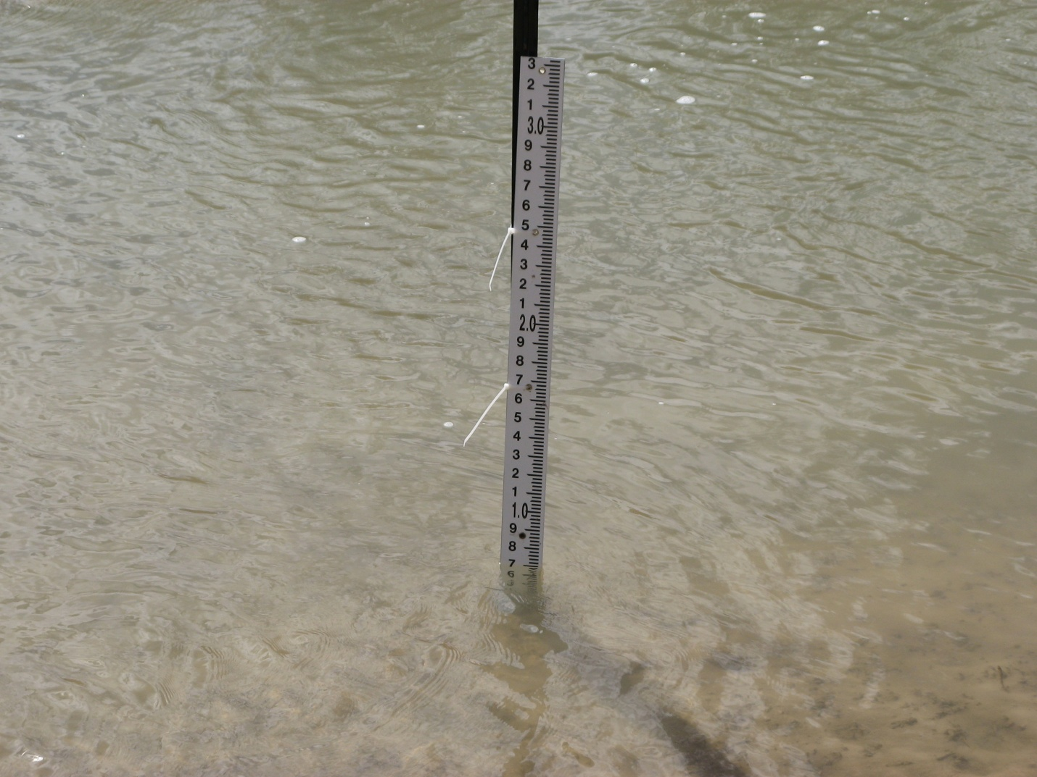
File Name: 087.jpg

Parachute Valley Gathering System Release, Project #2120
Date: 03-21-2013
Photographer: Karen Spray
Facing: west
Description: Middle gage in Parachute Creek. No evidence of impact in creek.

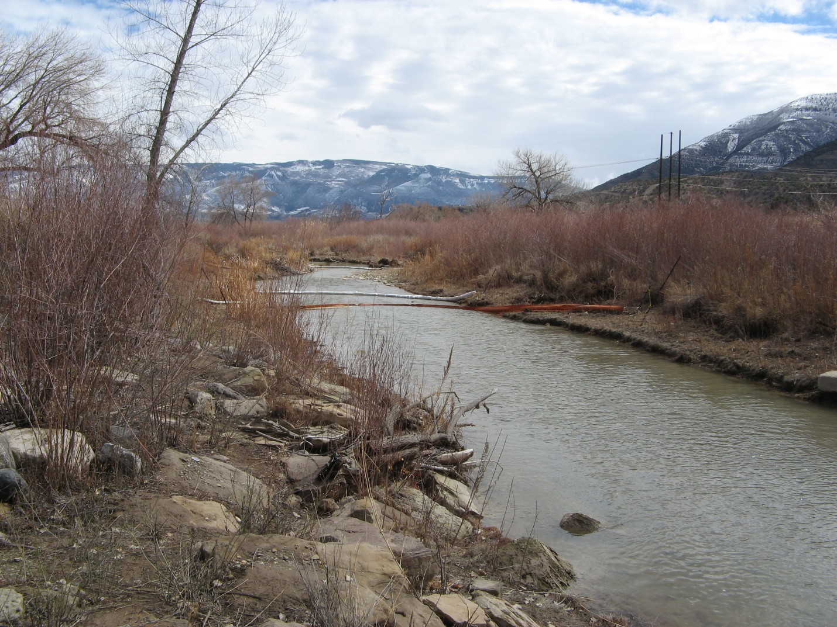
File Name: 088.jpg

Parachute Valley Gathering System Release, Project #2120
Date: 03-21-2013
Photographer: Karen Spray
Facing: south
Description: Parachute Creek downstream of excavation. Booms in place. No evidence of impact to creek.

