Reference Point for Chandler Creek 24-32 is the pin located 212' South and 24' East of Wellsite.

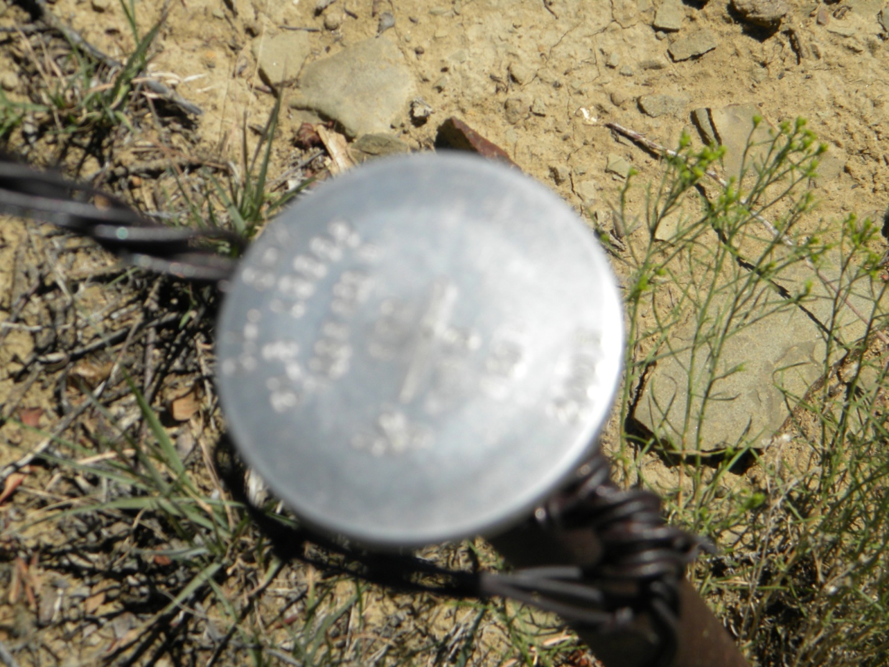

Reference Picture taken 08/11/2010 Direction- North
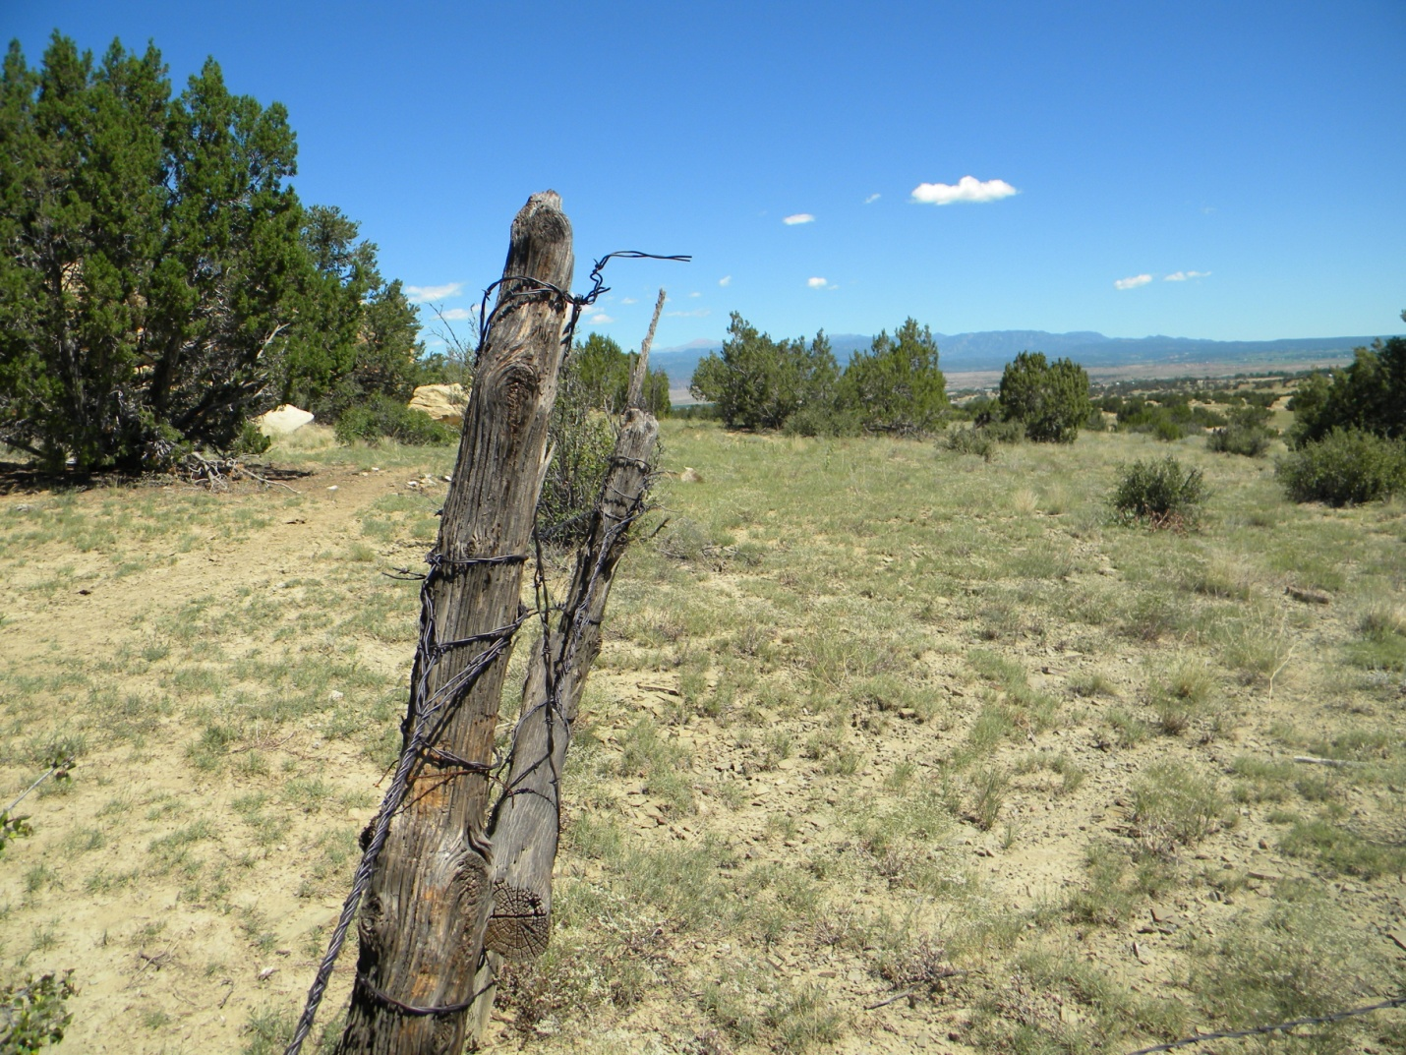

Reference Picture taken 08/11/2010 for Chandler Creek 24-32 Direction- West

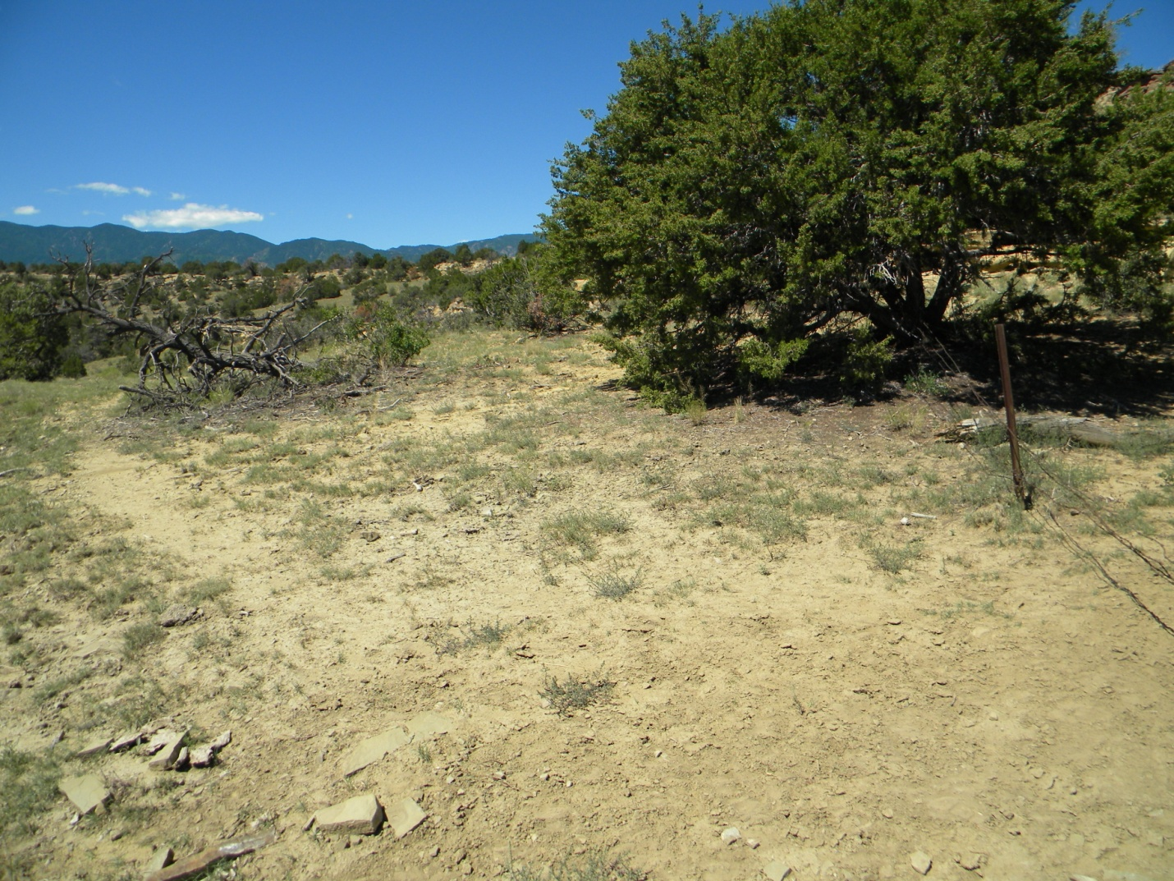

Reference Picture taken 08/11/2010 for Chandler Creek 24-32 Direction- South

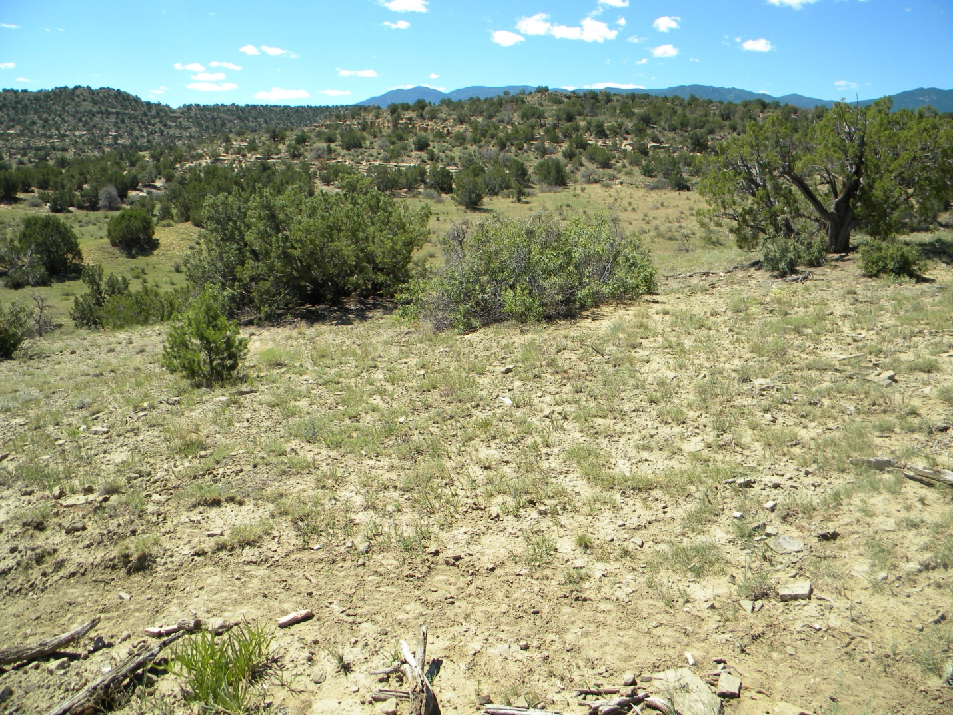

Reference Picture taken 08/11/2010 for Chandler Creek 24-32 Direction- East



